- Finalization & SAP Upload
- Revise the scope of this section. There will be no SAP automatic upload anymore.
- Revise the title to ‘Budget Finalization & Upload’
- Upon the final review of the Budget Officer, there will be a click button to finalize and upload the final budget in the system. Put time stamp.
- This uploaded budget per CC-GL will feed the budget data need across the system instead of pulling the budget data from SAP.
- Show a report per SBU of the final uploaded budget per CC-GL.
- Allow filtering/search of CC-GL.
- Put also the CC name and GL name.
- Retain the checking of total budget upload per SBU vs board-approved budget per SBU.
- Allow extraction of report to excel.
- This view is available to the Budget Officer only.
- Add a section for ‘Approved Budget’ under Module 1.
- Only the SBU Finance will have access to this. Don’t make it visible to other users. - include in the Admin Console (who will have access to this module)
- Users with access will only see the report for the SBU they belong to. – include in the Admin Console
- Under the sub-menu, add the ff SBUs:
- Malls
- Offices
- Estates
- Residential
- Leisure
- Corporate
- Inside each SBU, reflect the following reports (data comes from ‘Approved Budget’)
- Malls, Offices, Estates, Residential, Leisure
- DOE
- Revenue
- NPC
- Corporate
- GAE
- NPC
- Budget Utilization
- Add a module ‘Dash Flow Payment Request Ticket - Budget Check’ module.
- Budgeting System will be connected to Dash Flow Payment Request Ticketing.
- This is available only to SBU Finance Officers whom the Dash Flow ticket is submitted to for validation. – include in the Admin Console (who will have access to this module)
- All tickets under Dash Flow Payment Request will have a stage for SBU Finance Officer – ‘Budget Check’
- All tickets routed to SBU Finance Officer will be linked to the Budgeting System reflecting the ff details:
- Cost Center (CC)
- GL Account (GL)
- Request Amount (VAT exclusive)
- Budgeting System will automatically read the details above and check the budget availability per CC-GL level. Below is the status tagging of budget check:
- Request Amount > Available Budget – ‘No sufficient budget’ (color red)
- Request Amount < Available Budget – ‘Budget available’ (color green)
- Put a button to close the ticket. This will remove the ticket from the list to be validated. Retain history of the closed tickets.
- Put a button linked back to the Dash Flow ticket.
- Annual Budget Setting – New Request
- GAE, DOE, NPC and Revenue – put a ‘Open Spreadsheet Template’ button.
- This is a pre-populated live template with their locked category dropdowns embedded via Data Validation. The requestor opens the page and sees their usual line items already listed—they just tweak the numbers or add/remove specific rows as needed.
- There’s a customized template per SBU.
- Forecast – NPC
- Put ‘Open Spreadsheet Template’ button. Refer to the attached file ‘Budgeting System_NPC Forecast Template’ for the template to be used for ‘Open Spreadsheet Template’ button.
- This is a pre-populated live template. The NPC budget approved for the current calendar year is pre-populated here per NPC Code.
- IO details come from SAP.
- Replace the existing columns with what is in the template.
- Follow the formula in the template.
- Retain this function:
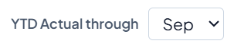
- Replace this list with NPC SBU list.
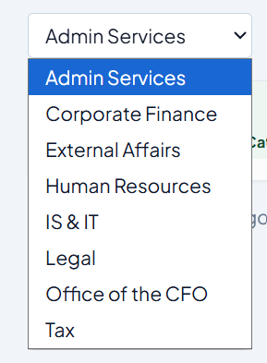
- The table function and ‘Open Spreadsheet Template’ button is not yet available this 2026 since there is no budgeting data for 2026 (to start only in 2027).
- For the meantime, the users can only use the ‘Upload Forecast Template’.
- Consider the ff. in the template:
- Calendar Year – make this hardcoded. Should follow the calendar year set in the system.
- SBU – make this a dropdown list of NPC SBUs
- Forecast – GAE, DOE, Revenue
- The ‘Open Spreadsheet Template’ button is not yet available this 2026 since there is no budgeting data for 2026 (to start only in 2027).
- This ‘Open Spreadsheet Template’ button is a pre-populated live template. The GAE, DOE, Revenue budget approved for the current calendar year is pre-populated here per Budget Code.
- For the meantime, the users can only use the ‘Upload Forecast Template’ then the table on the Dashboard will be updated once the filled-out template is uploaded.
- Consider the ff. in the template:
- Calendar Year – make this hardcoded. Should follow the calendar year set in the system.
- SBU – for DOE and Revenue, make this a dropdown list of SBUs; for GAE, hardcode ‘Corporate’.
- ‘Actual’ columns – reflect only the ‘YTD Actuals’ on the Dashboard table.

